**DATA BASE SYSTEMS LAB 6**

**Name: Ahmed Kasteer**

**Roll Number: 20F-0336**

**Section: 4D**

**AGENDA**

* **STRING FUNCTIONS**

**“Concatenation”**

SELECT ENAME + ' ' + JOB as CONCATENATE FROM EMP;

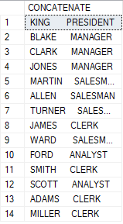

**“UPPER AND LOWER”**

SELECT UPPER(ENAME) AS EmployeeName, SAL FROM EMP;

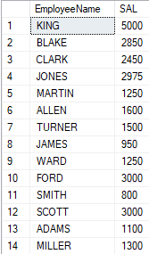

SELECT LOWER(ENAME) AS EmployeeName, SAL FROM EMP;

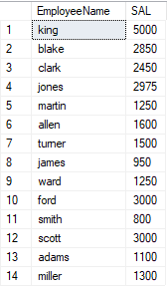

**“SUBSTRING”**

SELECT ENAME+ ' ' + JOB AS Name_Job, SUBSTRING(ENAME, 1,4) AS Substr FROM EMP;

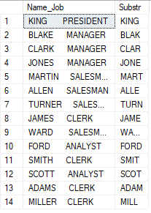

**“LENGTH”**

SELECT ENAME, LEN(ENAME) AS Length_is FROM EMP;

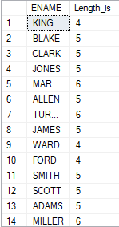

* **Numeric Functions**

**“CEILENG”**

SELECT p_descript, p_onhand, p_price, CEILING(p_price) AS Ceil_Price FROM p;

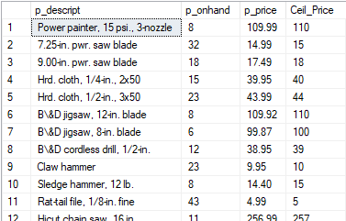

**“FLOOR”**

SELECT p_descript, p_onhand, p_price, FLOOR(p_price) AS Floor_Price FROM p;

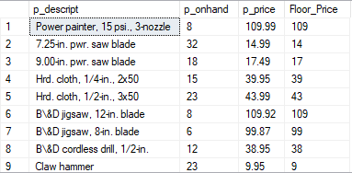

**“ROUND”**

SELECT p_descript, p_onhand, ROUND(p_price, 1) AS Price FROM p;

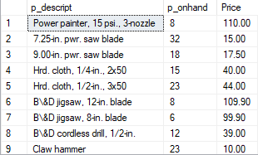

* **CONVERSION FUNCTIONS**

**“Numeric to Character”**

SELECT p_code, CONVERT(int, '999') AS price, p_onhand AS Quantity,CONVERT(int,

'99') AS Disc, CONVERT(int,'99999') AS Total_cost FROM p;

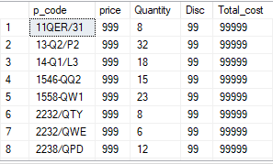

**“Date to Character”**

SELECT p_indate, CONVERT(varchar, '2003-11-03') AS date_h FROM p;

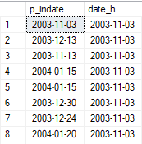

**“String to Number”**

SELECT p_indate, CAST(p_price AS Numeric(10,3)) AS Number FROM p;

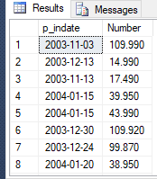

**“CASE/DECODE”**

SELECT p_descript, CASE WHEN p_discount = 0.05 THEN 'Moderate'

WHEN p_discount = 0.1 THEN 'High'

ELSE 'None' END AS Discount FROM p;

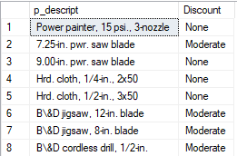

**“NVL/ISNULL”**

SELECT p_code, p_price, p_price*ISNULL(p_discount, 0) FROM p;

